How to set up a simple data connection over Qualcomm QMI interface using libqmi and driver qmi_wwan in IOT_GATEWAY

->limqmi yocto package recipe was added in IOT_GATEWAY
->after building the new image we got qmicli
library libqmi can be used to communicate with the cellular devices over the interface and do cellular module configurations to control and trigger the data connection over the cellular network.
qmicli --device=/dev/cdc-wdm0
qmicli -d /dev/cdc-wdm0
In order to ease usage of the QMI interface and handle parallell command requests, libqmi include a proxy function to handle it correctly on the QMI interface, To use it, make sure to have the the attribute present in the qmicli command:
-p
--device-open-proxy
Example commands on how to communicate
Request module manufacturer:
qmicli -p -d /dev/cdc-wdm0 --dms-get-manufacturer
Get module model:
qmicli -p -d /dev/cdc-wdm0 --dms-get-model
Get firmware version:
qmicli -p -d /dev/cdc-wdm0 --dms-get-revision
Get module IDs (IMEI etc.):
qmicli -p -d /dev/cdc-wdm0 --dms-get-ids
Get SIM card status:
qmicli -p -d /dev/cdc-wdm0 --uim-get-card-status
The script qmi-network can be used to establish a simple data connection, it will automatically try to verify the IP framing type match them correctly between qmi_wwan driver and module (Raw-IP vs. 802.3 IP framing).
Create a config file containing your network operator APN details and if needed, the username and password.
Save it e.g. in the default location /etc/qmi-network.conf
The parameter --profile=[PATH] can be used to define the path to config when executing qmi-network.
Example config file content: APN details and enabling of proxy usage.
Add the username and password lines if it is needed for your APN:
APN=my-network-operators-apn
APN_USER=my-apn-username
APN_PASS=my-apn-password
PROXY=yes
Once the APN information is saved, you can start the network connection with the command:
qmi-network /dev/cdc-wdm0 start
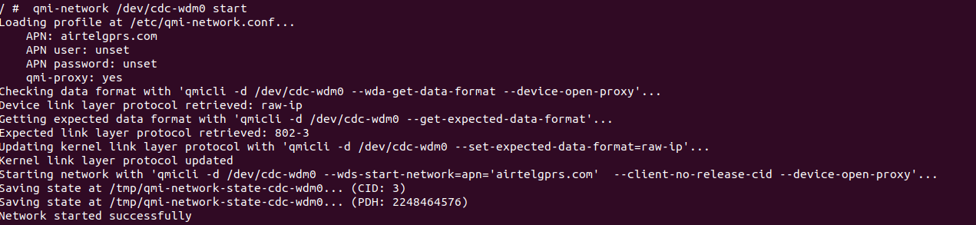
The name of the related network interface in the Linux system can be acquired with the command:
qmicli -p -d /dev/cdc-wdm0 --get-wwan-iface
Once you see "Network started successfully" message, you can send a DHCP request on the network interface.
Please note that not all DHCP clients in Linux can handle Raw-IP format but udhcpc support it.
udhcpc -q -f -i wwan0

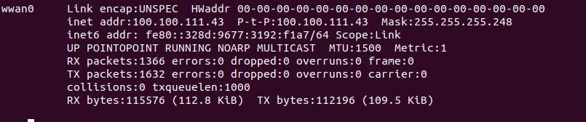
The IP information from the cellular network can also be acquired and set manually to the network interface by the user or scripting, the correct address details can be acquired from the cellular module over QMI with command:
qmicli -p -d /dev/cdc-wdm0 --wds-get-current-settings
If the connection was successfully set up and established, you now have a data connection. Ping request to a remote server using the cellular network interface can prove this:
ping -I wwan0 8.8.8.8
